Tableau Parts 11 and 12: Exercises with answers

Exercise 11

- Import the state_data.csv data into Tableau.

- Make a map of Population for all States using Longitude and Latitude

Answer:

Drag:
- Longitude to columns
- Latitude to rows
- Population to the marks color panel
- State name to the detail panel
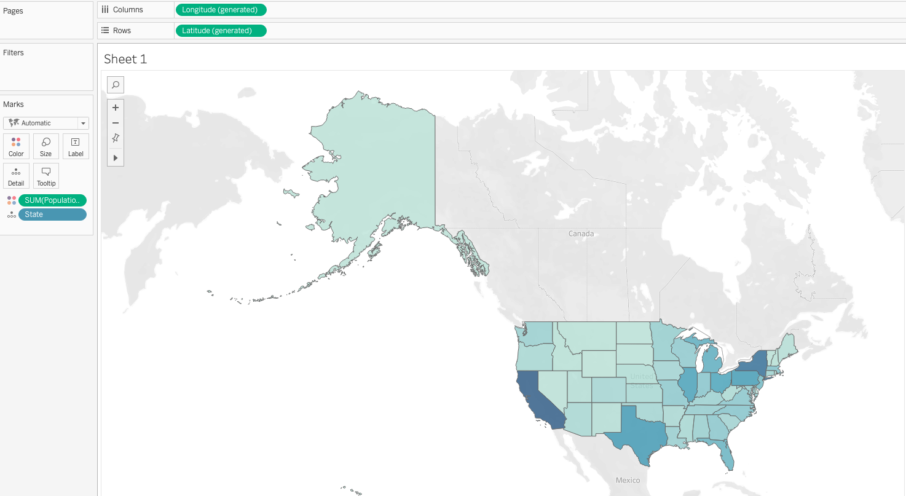

- Insert a Map Scale using the Map option.

Answer: Map -> Map option -> Check Show Map Scales
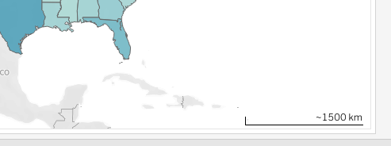

- Using Map Layer options, change the style to Outdoors. Check the map options “Terrain” and “Water Labels.”

Answer: Map ->Background Layers

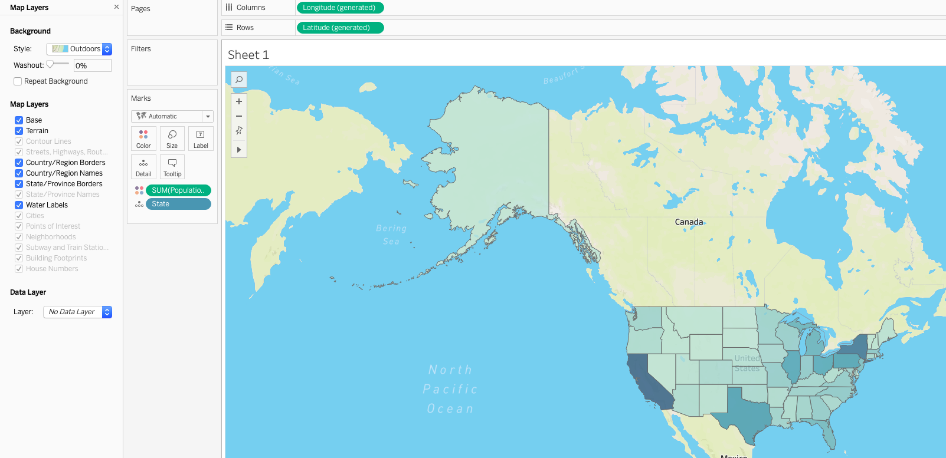
- Zoom into the California area to have a better look at the state details.

Answer:
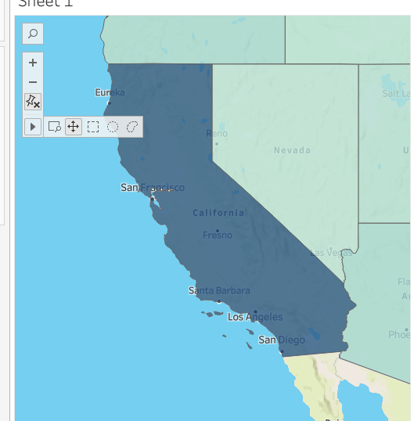

- Convert the ‘code’ dimension to geospatial data to recognize that the codes are State codes. Replace the `State` variable with `code`.

Answer:
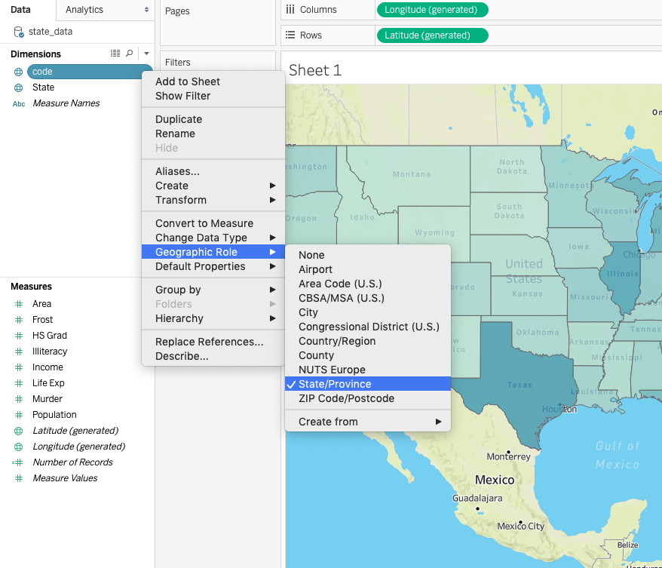

- Identify the issues with the geospatial data when we switched to state codes.

Answer: Alaska is not shown on the map and there are two
unrecognized locations.
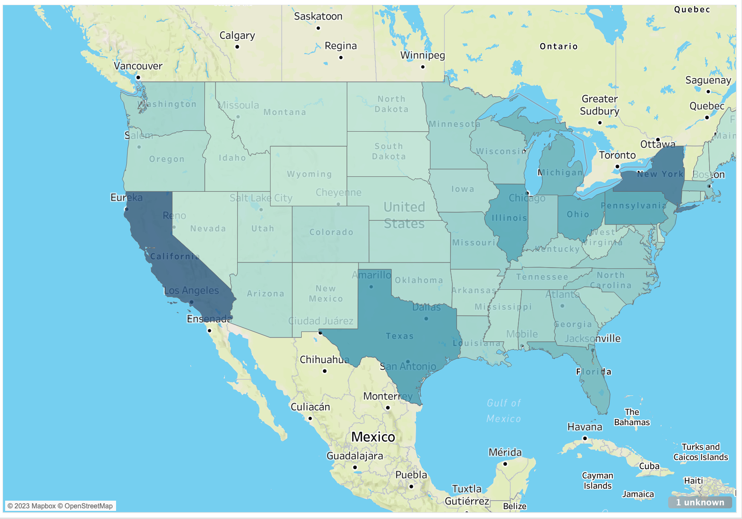
- Fix the issues using the Edit Locations window. Update the locations for ‘Alaska’ and ‘Vermont.’ (Hint : Click on ‘unknown’ in bottom right corner of the map to open ‘Edit Locations’)
Answer:

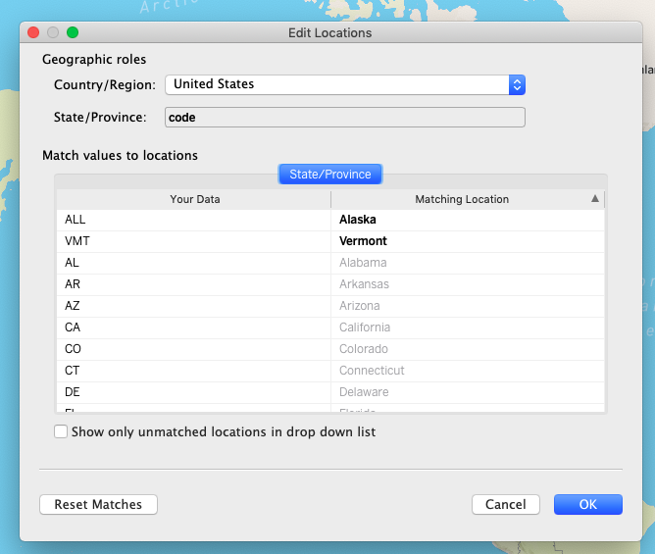

Exercise 12

Let your instructor know if you would like to share your dashboard as an example answer. Your dashboard will likely differ from your colleagues’.

